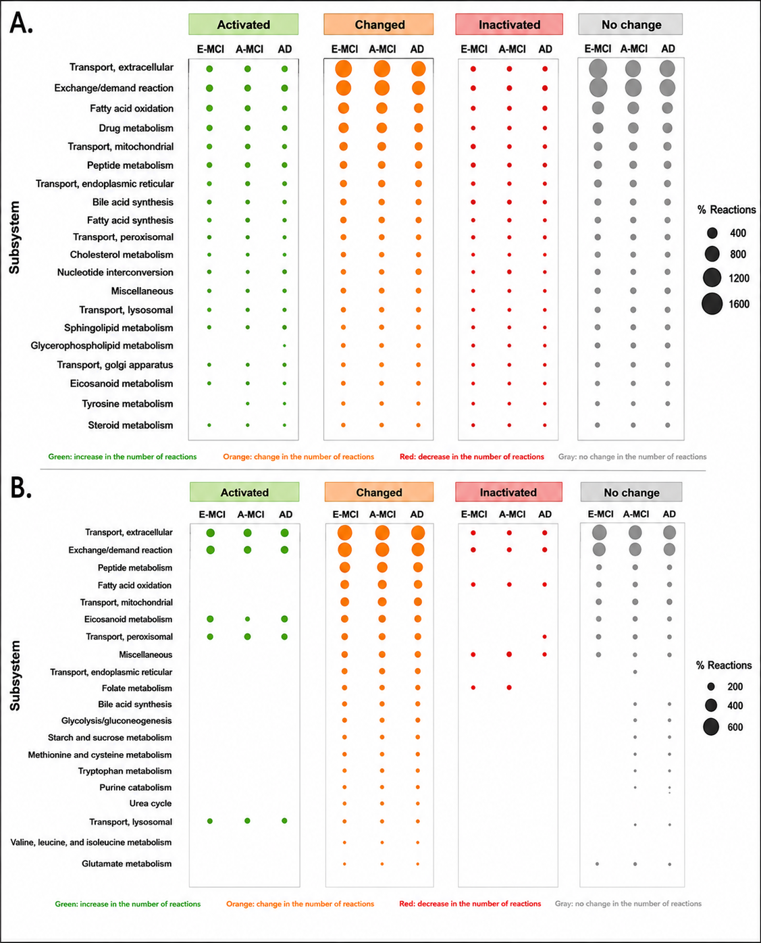
Supplementary Figure S1. Reaction-level classification of contextualized metabolic models across the MCI–AD continuum. (A) Astrocyte and (B) GABAergic neuron contextualized metabolic models showing the distribution of reactions classified into four categories after comparison with the corresponding Control model: Activated (reactions inactive in Control but active in the disease model), Changed (reactions active in both conditions but exhibiting different flux values), Inactivated (reactions active in Control but inactive in the disease model), and No change (reactions remaining active with unchanged flux values). Results are presented for Early Mild Cognitive Impairment (E-MCI), Advanced Mild Cognitive Impairment (A-MCI), and Alzheimer's disease (AD). Reactions are grouped according to their assigned metabolic subsystem. Bubble size represents the percentage of reactions within each subsystem belonging to the corresponding category. Thus, larger bubbles indicate that a greater fraction of reactions in that subsystem underwent the indicated change. Colors are used to facilitate visualization of the four reaction classes: green, activated; orange, changed; red, inactivated; and gray, unchanged. Across disease progression, most altered reactions were classified as Changed, indicating that the majority of metabolic reactions remained active but operated at modified flux values under transcriptome-derived constraints. In contrast, relatively few reactions became newly activated or completely inactivated. Transport-associated processes, lipid metabolism, mitochondrial transport, peptide metabolism, and fatty acid oxidation accounted for the largest proportion of altered reactions, supporting the interpretation that disease progression primarily induces redistribution of existing metabolic fluxes rather than extensive gain or loss of metabolic functions.

